Capstone Project – Pre-Submission Document
LearnSphere Education Technologies: Learner Success and Dropout-Risk Analytics
1. Business Problem Understanding and Objective Formulation
Context. LearnSphere earns revenue and reputation from learners who finish and get certified, not merely enrol. Enrolments are growing while completion falls, enterprise clients question employee completion, and support is reactive: learners are helped only after falling behind. Leadership has set no fixed analytical target, so the team must find what separates successful from unsuccessful learners.
Problems found in the dataset (50,500 rows, 37 columns; 50,000 unique learners after de-duplication; preliminary profiling):
- Completion gap: 44.9% of learners did not succeed (55.1% success). The outcome flag student_success_flag matches certificate_issued_flag in every row, so “success” means certification.
- Behaviour, not profile, separates outcomes: success rates differ by under 2 points across gender, education, employment, course category, difficulty and enrolment type. Quiz average, video completion, attendance, assignment completion, study hours, engagement, learning streak and mentor contact show the strongest links (correlation 0.11 to 0.24).
- Threshold effect: learners in the top quartile of attendance or quiz score succeed about 77% of the time, against 45 to 53% in the other quartiles, so risk is concentrated in a nonlinear pattern.
- Contrary to assumptions: forum posts, peer interaction, midterm, final project and satisfaction scores show almost no association with success, which challenges the beliefs of several departments and must be validated.
Business objectives. (BO1) Raise the certification rate by moving from reactive to proactive support; (BO2) identify the behaviours that drive success and dropout; (BO3) give student-success teams a ranked at-risk list and targeted intervention playbook within their capacity.
Analytical objectives. (AO1) audit and clean the data; (AO2) test which variables are statistically linked to success; (AO3) build a leakage-free binary classifier for student_success_flag; (AO4) evaluate with ROC-AUC, PR-AUC, recall and precision on non-completers, and calibration; (AO5) explain predictions with SHAP and segment learners into risk personas; (AO6) convert findings into thresholds and recommendations. Proposed success criterion: ROC-AUC ≥ 0.85 on held-out data, with cut-offs agreed with student-success teams.
2. Challenges and Constraints
- Data quality: 500 exact duplicate records (1%); about 10% missing values in mentor_interaction_count and feedback_score (missingness is unrelated to outcome); employment_status written three ways (Professional, PROFESSIONAL, professional); course_fee reaching 1,000,000 against a median near 77,000; and legacy or administrative fields (legacy_student_reference, administrative_code, batch_reference, learning_cluster_id) with no business meaning and no link to success.
- Target leakage and timing: certificate_issued_flag is the outcome itself and must be excluded. Late-stage fields such as final_project_score would not exist when an early warning is needed, and the data is a single snapshot with no timestamps, so true week-by-week early detection cannot be tested directly.
- Modelling: individual linear signals are weak and predictors are largely independent, yet a quick gradient-boosting baseline reached ROC-AUC ≈ 0.92 against ≈ 0.82 for logistic regression (5-fold CV, 13 behavioural features), so the trade-off between accuracy and interpretability matters.
- Deployment and adoption: six source systems need consistent weekly refresh; models need drift monitoring; privacy and fairness (age, gender) need review; teams must trust the scores, so explanations are essential. False positives waste limited mentor time and false negatives lose learners. Prediction is not causation, so interventions need a controlled pilot.
Assumptions and limitations. Each row is one learner-course enrolment; duplicates are system errors; behavioural fields are measured before the outcome is decided (to be confirmed with the business); “at risk” means predicted non-success; the data is observational with no intervention history, so recommendations are hypotheses to be tested.
3. Background Study / Literature Review
- Early dropout prediction: Kloft et al. (2014) predicted MOOC dropout week by week from simple clickstream features, showing that behaviour logs alone give useful warnings. Kizilcec, Piech and Schneider (2013) clustered MOOC learners by engagement trajectory, supporting our learner segmentation.
- Industry practice: Purdue’s Course Signals (Arnold and Pistilli, 2012) turned grades and effort data into a traffic-light risk indicator for instructors and reported retention gains, although later critiques questioned causal attribution. A systematic review of 689 articles (Larrabee Sønderlund et al., 2019) found only 11 that evaluated learning-analytics interventions, with promising but moderate-quality evidence, which motivates our A/B pilot.
- Recent evidence: Rahmani, Groot and Rahmani (2024) reviewed 110 studies of online higher-education dropout and linked it to course quality, academic preparation, satisfaction, motivation, system attributes and support services, which supports analysing behaviour, experience and support together.
- Data and methods: Kuzilek et al. (2017) released the Open University Learning Analytics Dataset, a common benchmark combining activity and assessment data. Romero and Ventura (2020) survey educational data mining and highlight at-risk classification, ensemble methods and growing demand for interpretability.
- Techniques: gradient-boosted trees (Chen and Guestrin, 2016) suit tabular behavioural data; SHAP (Lundberg and Lee, 2017) explains individual predictions; Kaufman et al. (2012) warn about leakage, a live risk here.
Best practices adopted: de-duplicate before splitting, remove leakage, start from an interpretable baseline, compare with ensembles, tune thresholds for operational cost, explain every score, use scores to support human decisions rather than penalise learners, and validate interventions experimentally.
4. Proposed Methodology / Solution Approach
We frame the problem as supervised binary classification of student_success_flag, supported by segmentation. After cleaning, we engineer features such as study hours per course week, assignment-to-video ratios, a composite engagement index, net fee after scholarship, and a mentor-missing indicator. We train a logistic regression baseline, Random Forest and XGBoost with stratified 5-fold cross-validation and a 20% hold-out set, tune hyperparameters, choose the cut-off by intervention cost, and interpret results with SHAP and K-means personas.
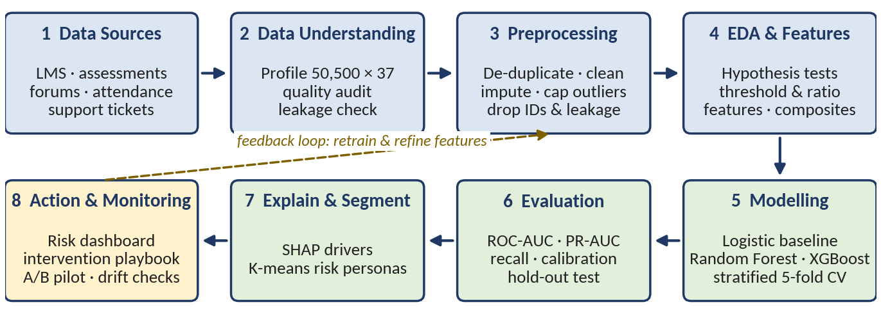
Figure 1. Proposed end-to-end analytics workflow
How it addresses the problem: the model gives each learner a risk score with top contributing factors; personas and thresholds (for example, low attendance combined with low quiz scores) trigger specific actions such as mentor outreach, nudges or content support; the pilot measures whether completion actually improves. Scores guide staff judgement and are never used to penalise learners.
5. Proposed Timeline
Weeks | Activities | Milestone
1 | Domain study, literature review, data understanding and profiling | Data dictionary, pre-submission
2 | Preprocessing: de-duplicate, standardise, impute, cap outliers, remove leakage | Cleaned dataset and cleaning log
3 | EDA, hypothesis tests, feature engineering | EDA report and insights
4 to 5 | Model development: baseline, ensembles, tuning | Candidate models
6 | Evaluation, SHAP, segmentation, threshold selection | Selected model and personas
7 | Dashboard, recommendations, deployment proposal | Dashboard and playbook
8 | Final report, presentation, rehearsal | Final submission
Weeks are relative and will be mapped to the official deadlines.
6. Expected Deliverables / Outputs
- Data quality and cleaning report; exploratory data analysis report with key drivers of success
- Machine learning models (baseline and tuned ensemble) with documented, reproducible code
- Evaluation and explainability report (metrics, SHAP drivers, learner risk personas)
- Interactive dashboard of at-risk learners and engagement indicators
- Business recommendations and intervention playbook, plus a deployment proposal (weekly batch scoring, monitoring, A/B pilot)
- Technical documentation and final presentation
Conclusion. The project combines rigorous data auditing, leakage-free prediction, explainability and tested interventions into a practical learner-success framework. Success will be judged by predictive performance, the usefulness of the insights, and evidence from a pilot that earlier support improves completion.

